Terna Engineering College
Computer Engineering Department

Program: Sem VII

Course: Artificial Intelligence & Soft Computing (AI&SC)

Experiment No. 05
PART B
(PART B: TO BE COMPLETED BY STUDENTS)
(Students must submit the soft copy as per the following segments within two hours of the practical. The soft copy must be uploaded on the Blackboard or emailed to the concerned lab in charge faculties at the end of the practical in case there is no Blackboard access available)

Roll No. 50 | Name: AMEY THAKUR
Class: BE-COMPS-50 | Batch: B3
Date of Experiment: 24-08-2021 | Date of Submission: 24-08-2021
Grade :

Aim: Identify the Classification problem and create a Knowledge database for that problem and apply appropriate search methods for optimization.
B.1 Software Code written by student:
(Paste your Problem Statement for Classification and Data set Used as a knowledge Database for Given Classification Problem)
Problem Statement
To categorise the flower dataset in order to determine if it is in stock or not, using a combination of classifiers, evaluators, and search algorithms to improve accuracy and compare findings.
B.2 Input and Output:
(Paste your screenshot of Analysis of Data, Relevant Attributes Selection by using at least Three methods)
Flowers.arff
@relation Flowers
@attribute Type {Lilies, Orchids, Roses, Tulips}
@attribute Color {Red,Yellow,Blue}
@attribute Feature {Fresh,Luster,Vibrance,Strong}
@attribute InStock {Yes,No}
@data
Lilies Red Fresh Yes
Orchids Blue Luster Yes
Orchids Yellow Fresh Yes
Tulips Red Strong No
Lilies Yellow Vibrance Yes
Tulips Red Fresh No
Roses Yellow Strong No
Roses Blue Luster Yes
Lilies Blue Strong Yes
Orchids Red Vibrance Yes
Roses Yellow Fresh Yes
Tulips Red Luster No
Tulips Yellow Strong No
Roses Blue Vibrance Yes
Orchids Blue Luster Yes
Orchids Red Strong No
Lilies Blue Fresh Yes
Tulips Yellow Vibrance No
Roses Red Luster Yes
Roses Yellow Strong No
Lilies Red Vibrance Yes
Orchids Blue Fresh Yes
Lilies Red Fresh Yes
Tulips Yellow Vibrance No
Roses Blue Luster Yes
Roses Red Strong No
Lilies Red Luster Yes
Orchids Yellow Fresh Yes
Tulips Red Luster No
Roses Blue Fresh Yes
Lilies Blue Fresh Yes
Lilies Red Strong No
Orchids Red Fresh Yes
Tulips Yellow Vibrance No
Orchids Blue Luster Yes
Tulips Yellow Strong No
Lilies Red Vibrance Yes
Tulips Red Luster No
Roses Blue Strong No
Orchids Blue Vibrance Yes
Orchids Red Vibrance Yes
Roses Yellow Fresh Yes
Tulips Blue Luster No
Lilies Yellow Strong No
Roses Red Vibrance Yes
Orchids Blue Luster Yes
Tulips Red Fresh No
Lilies Blue Strong No
Tulips Yellow Luster No
Orchids Red Luster Yes

Weka
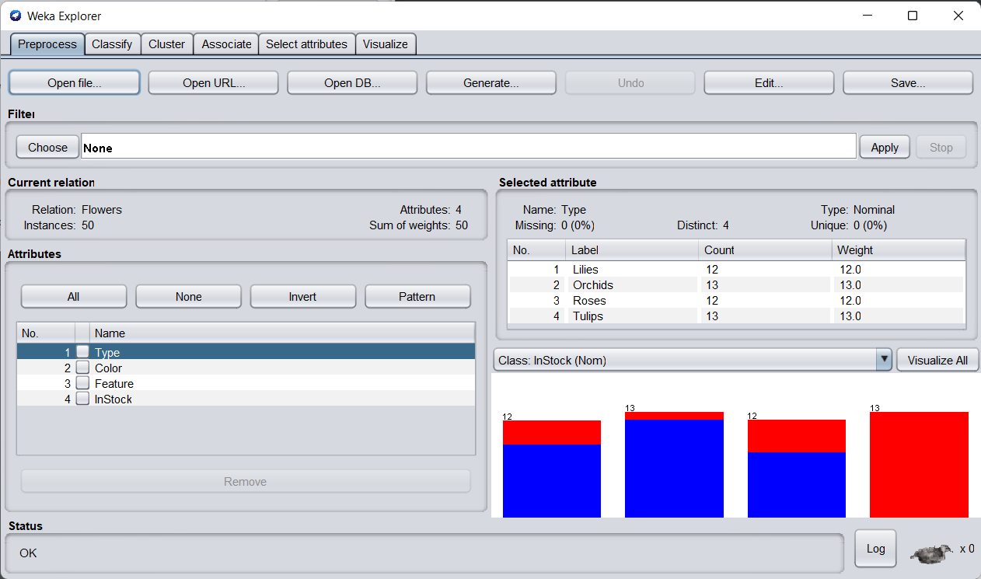
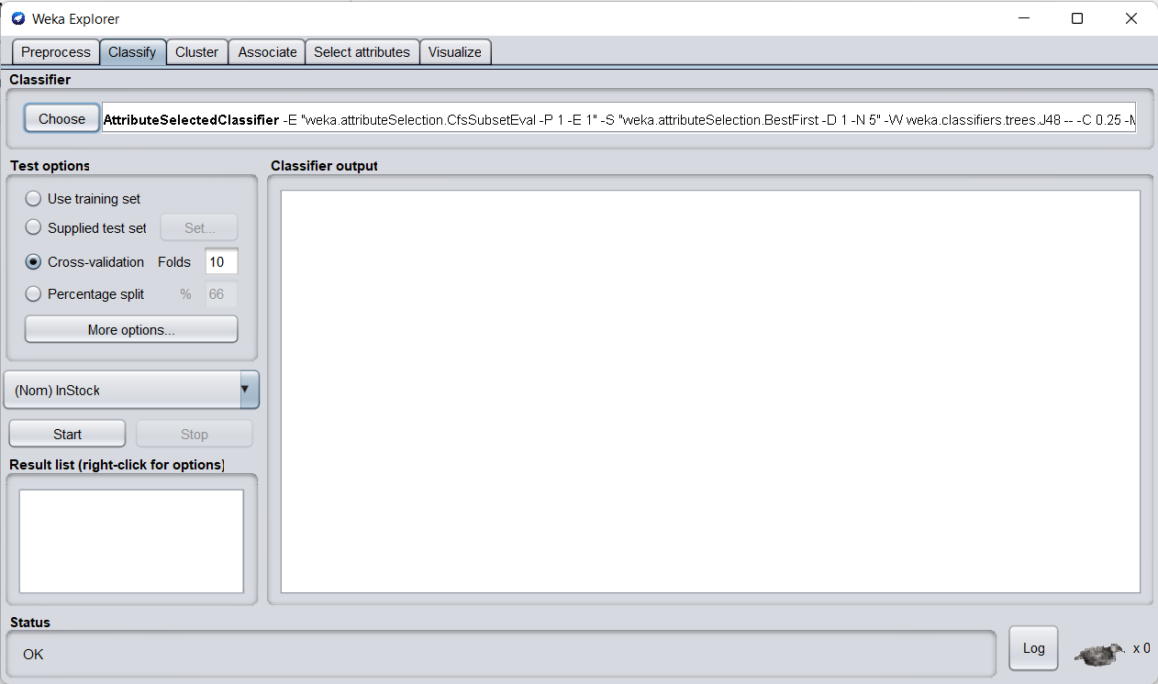
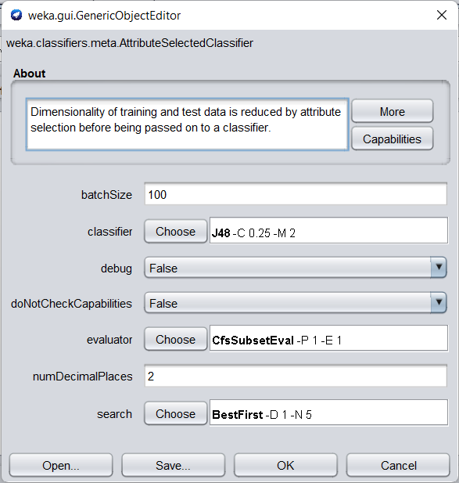
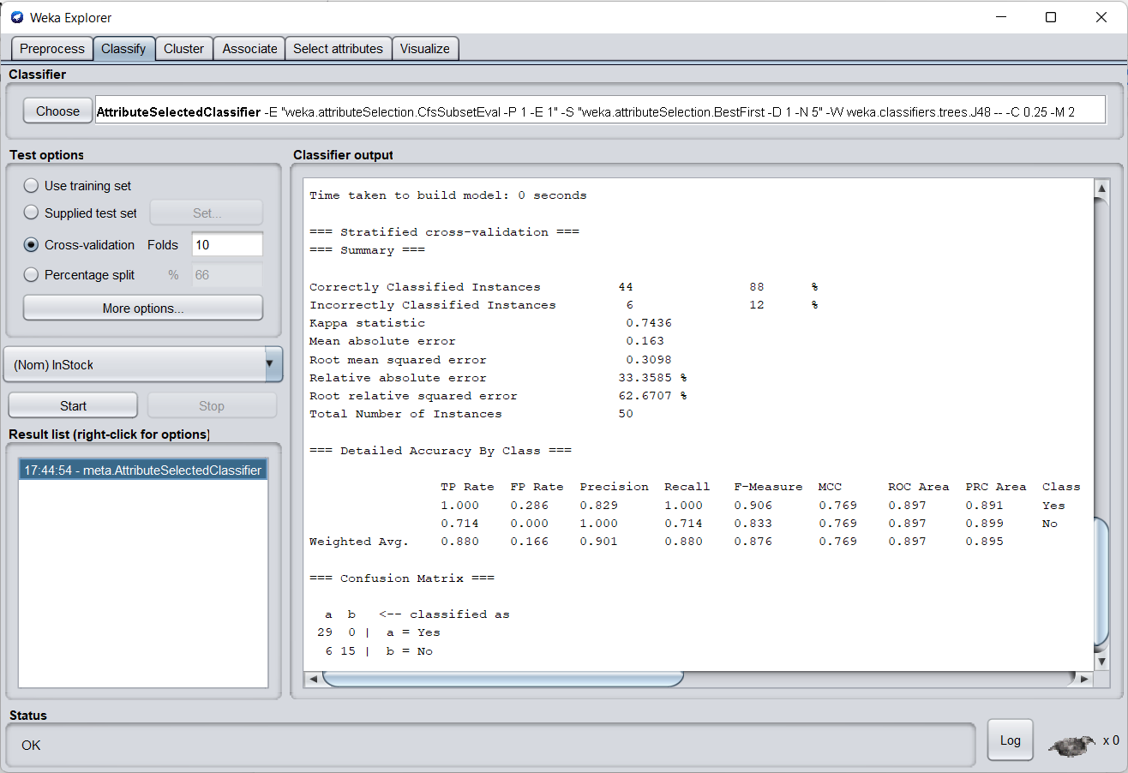
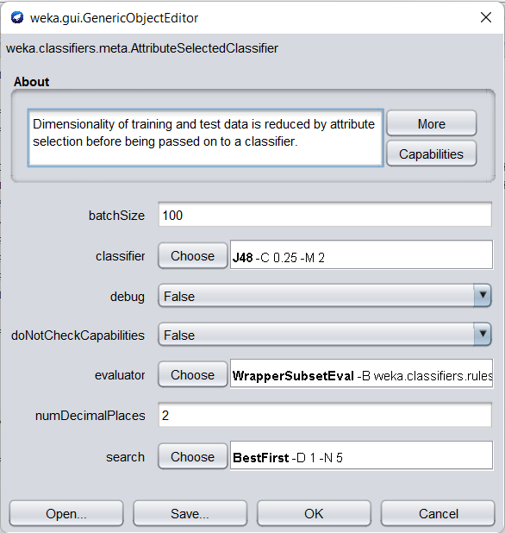
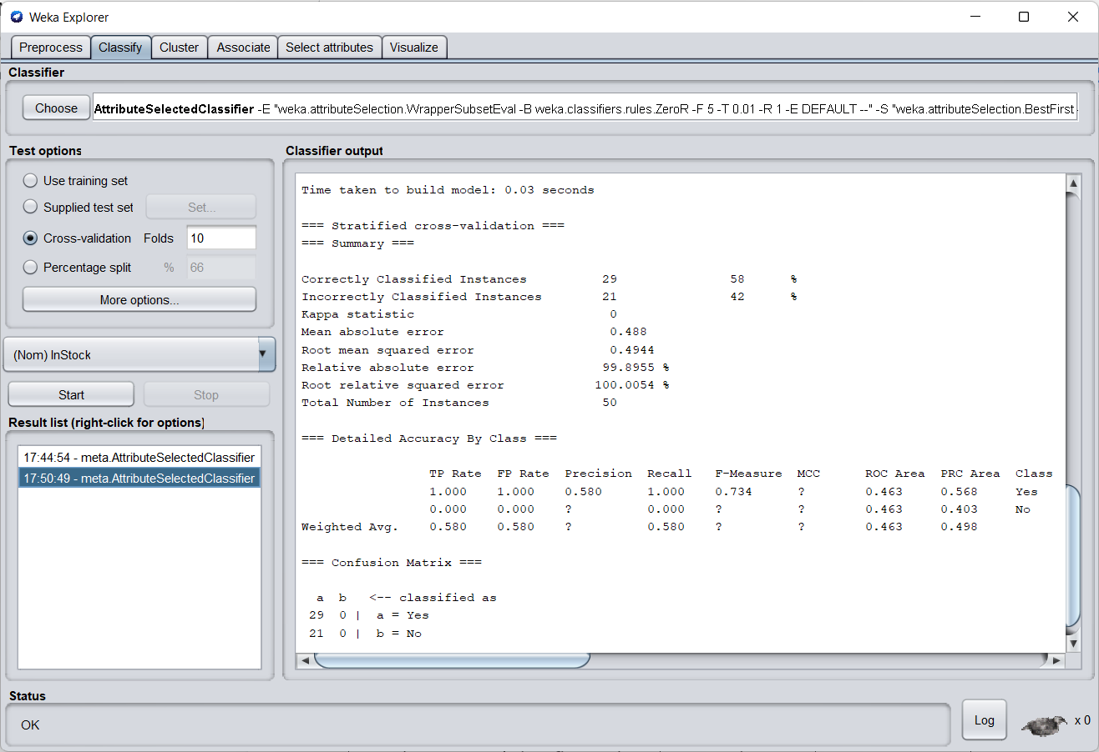
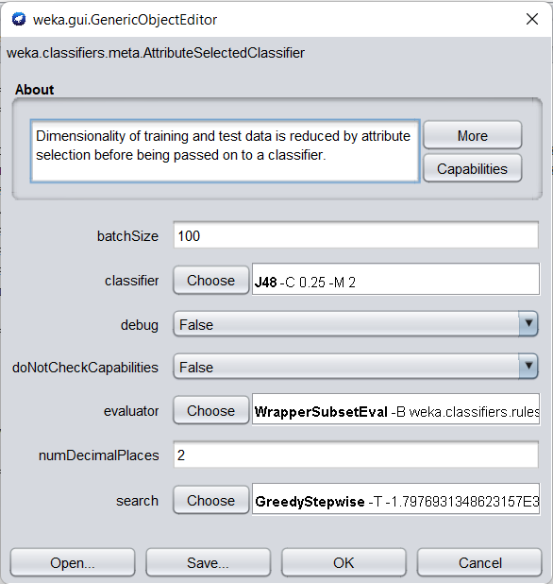
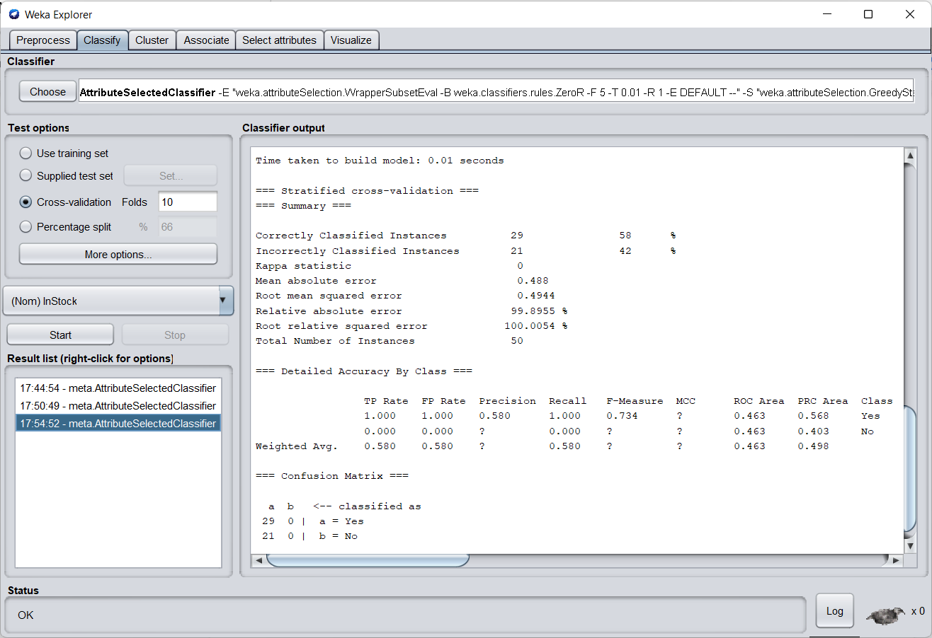
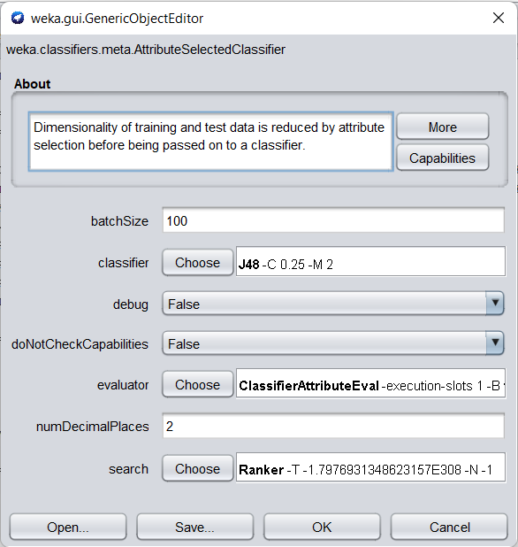
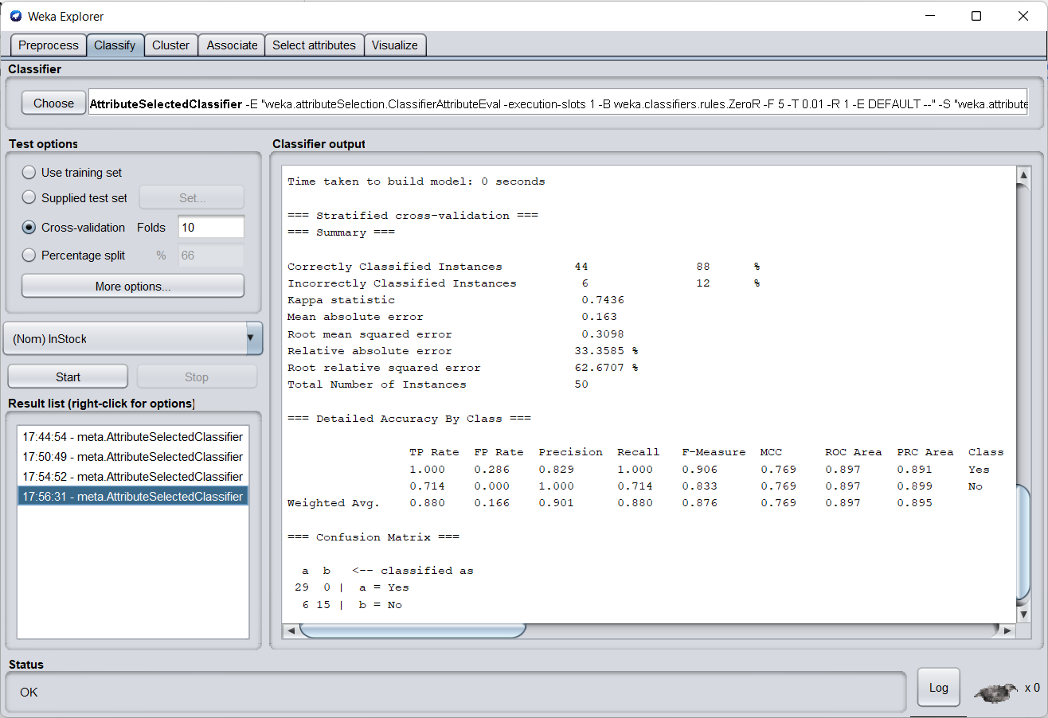
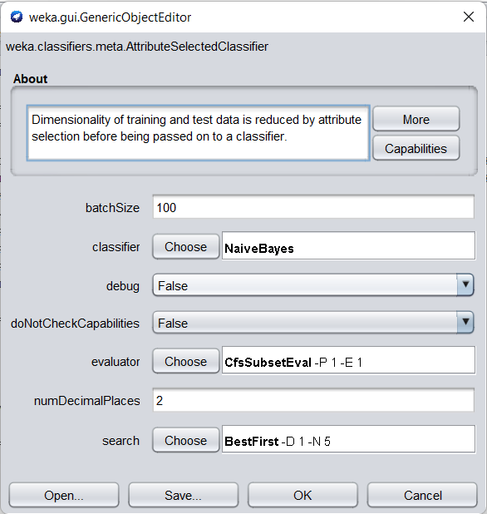
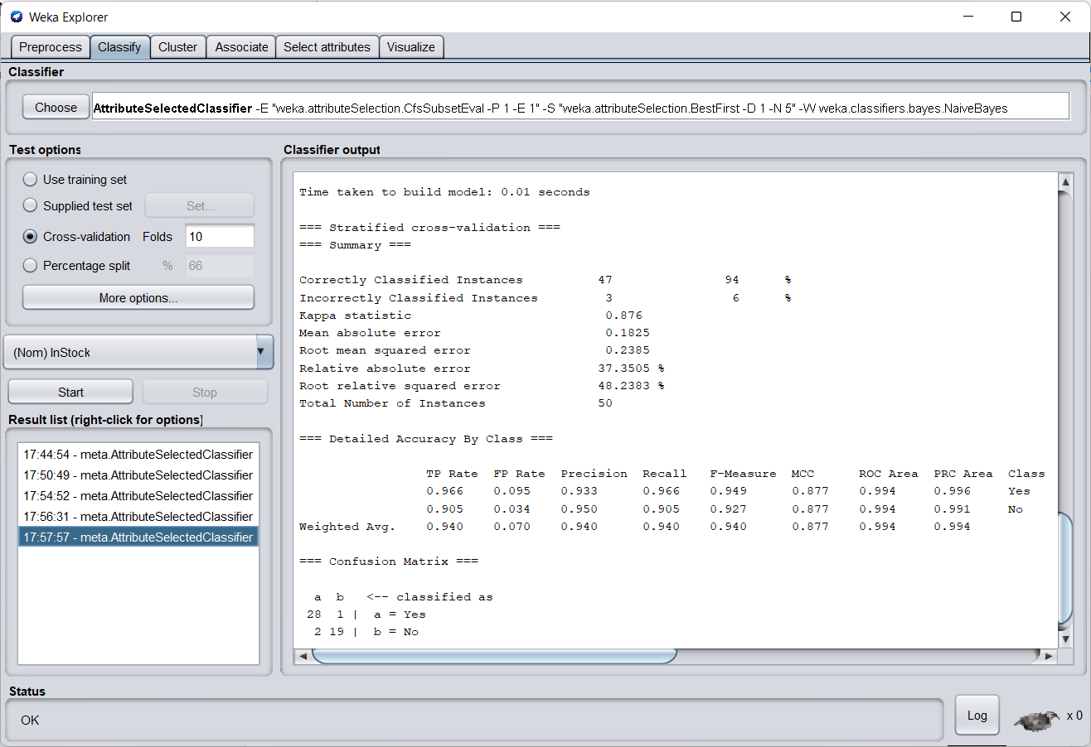
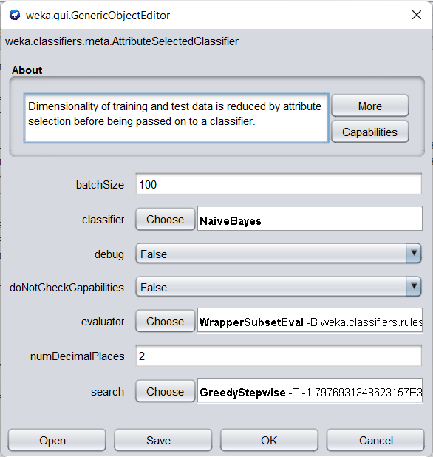
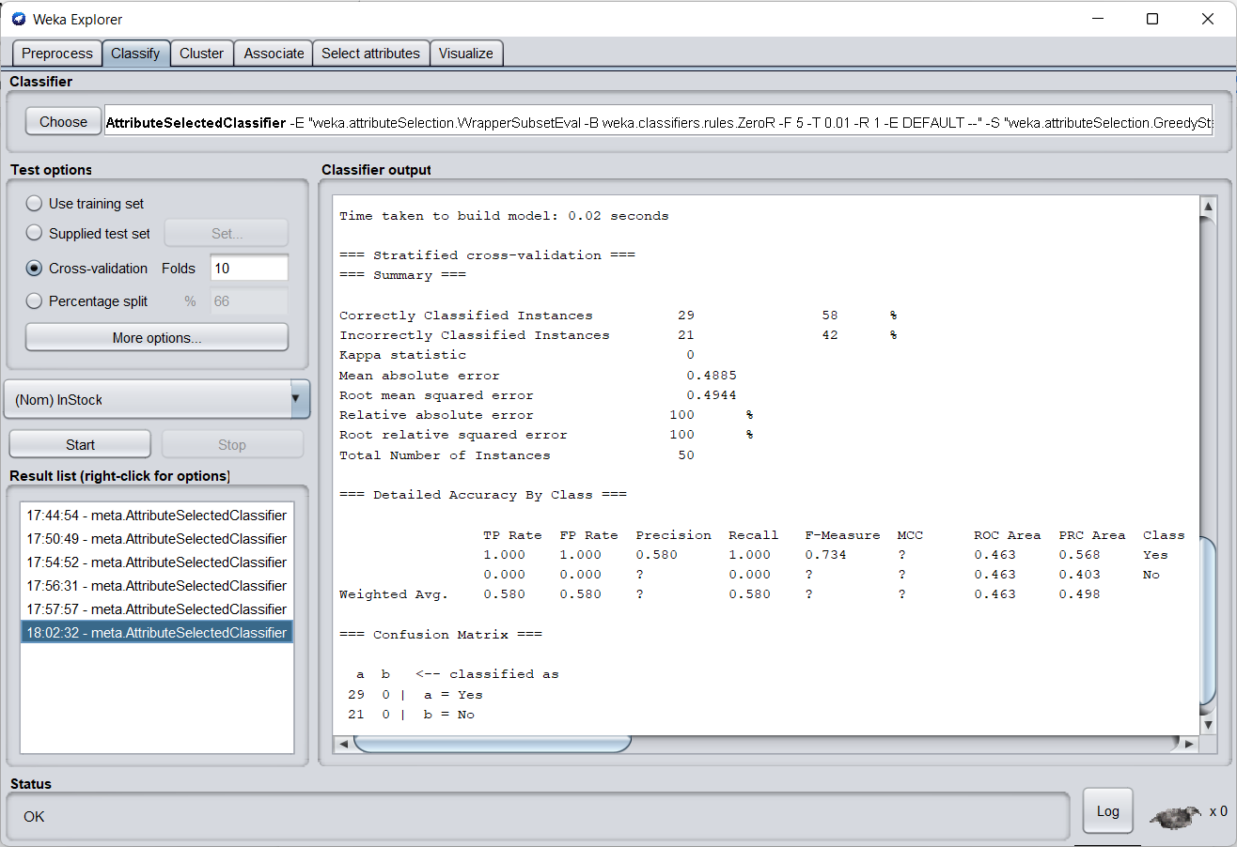
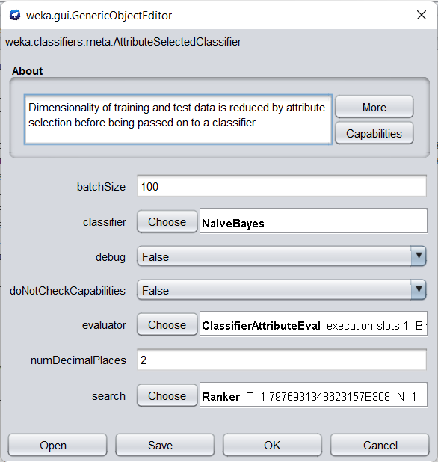
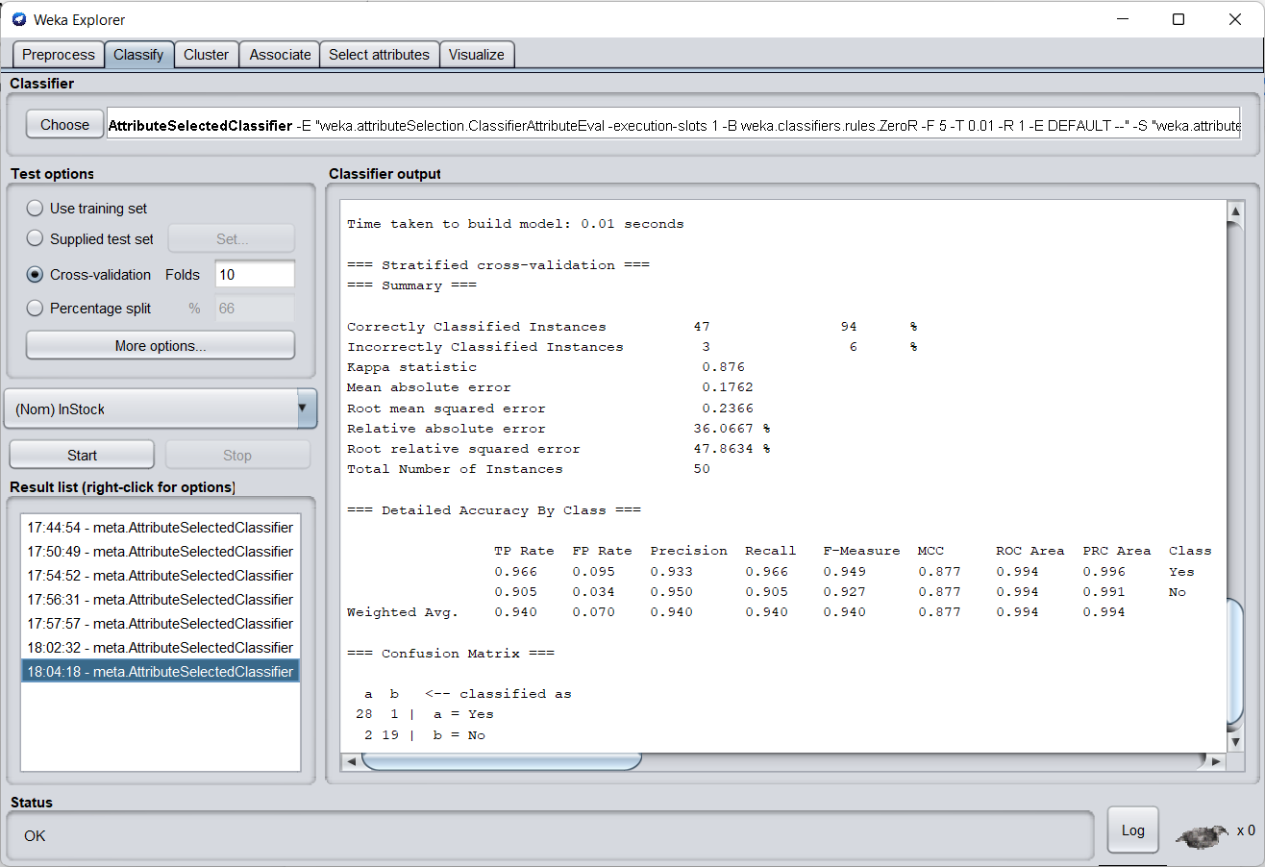
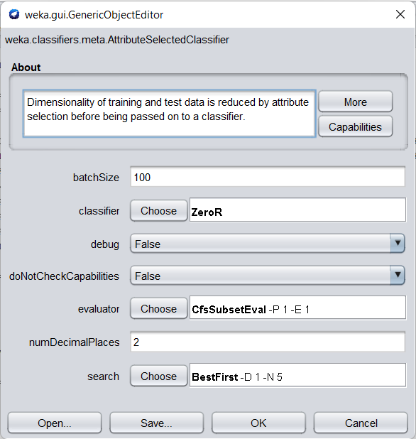
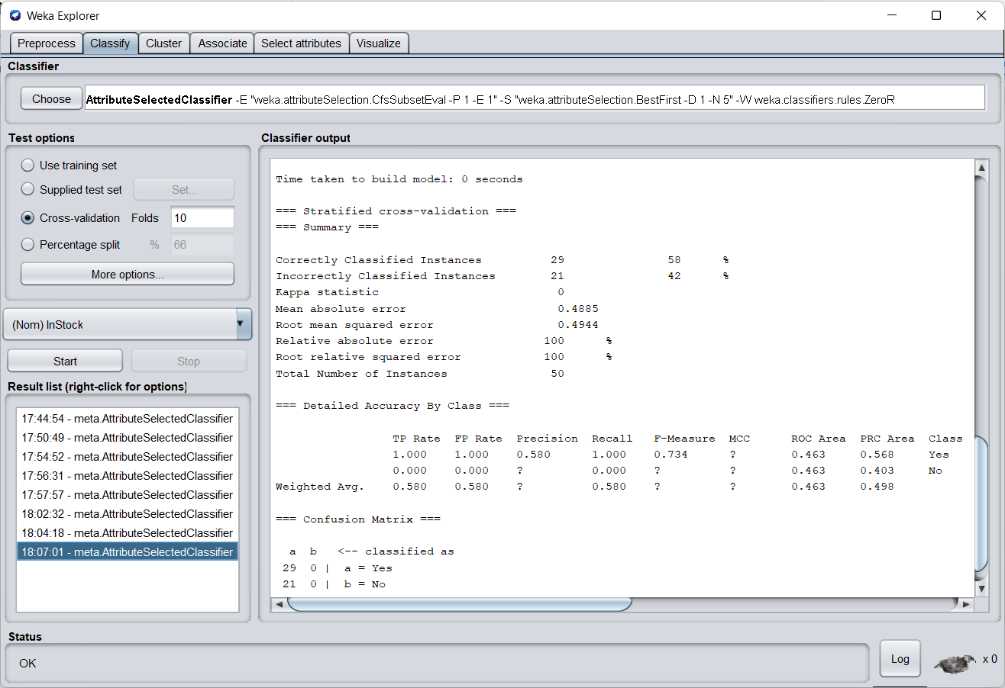
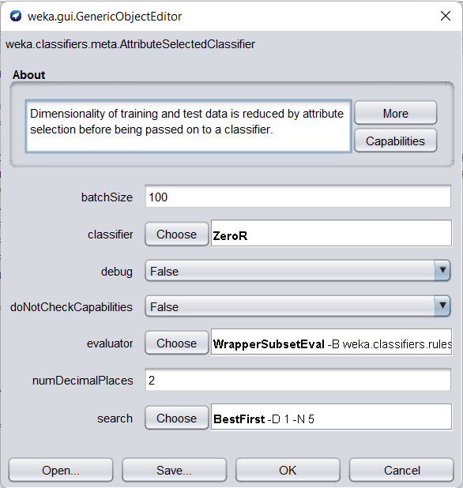
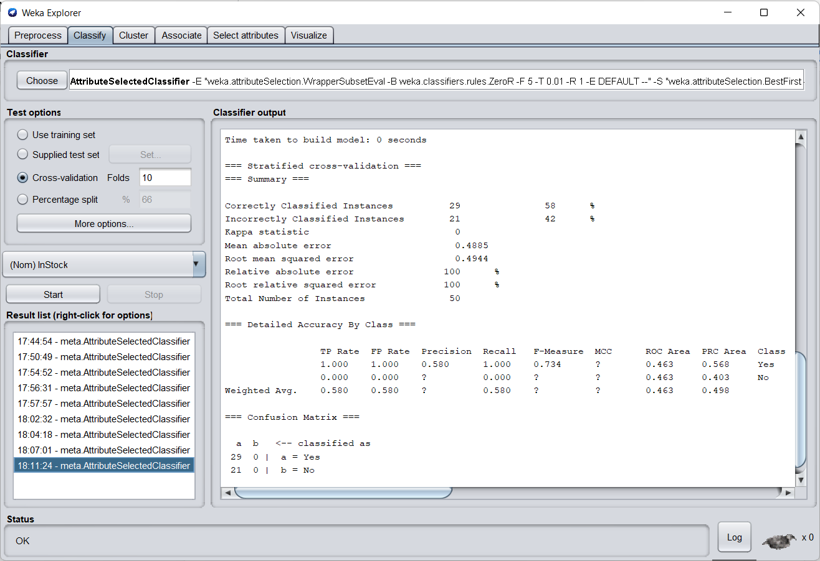
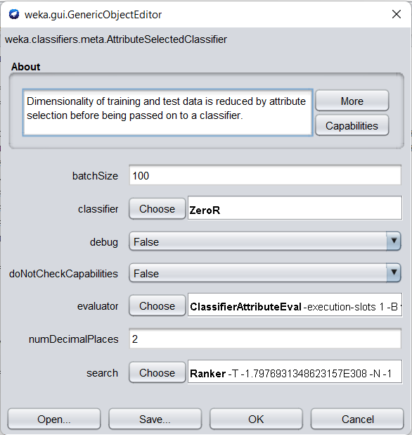
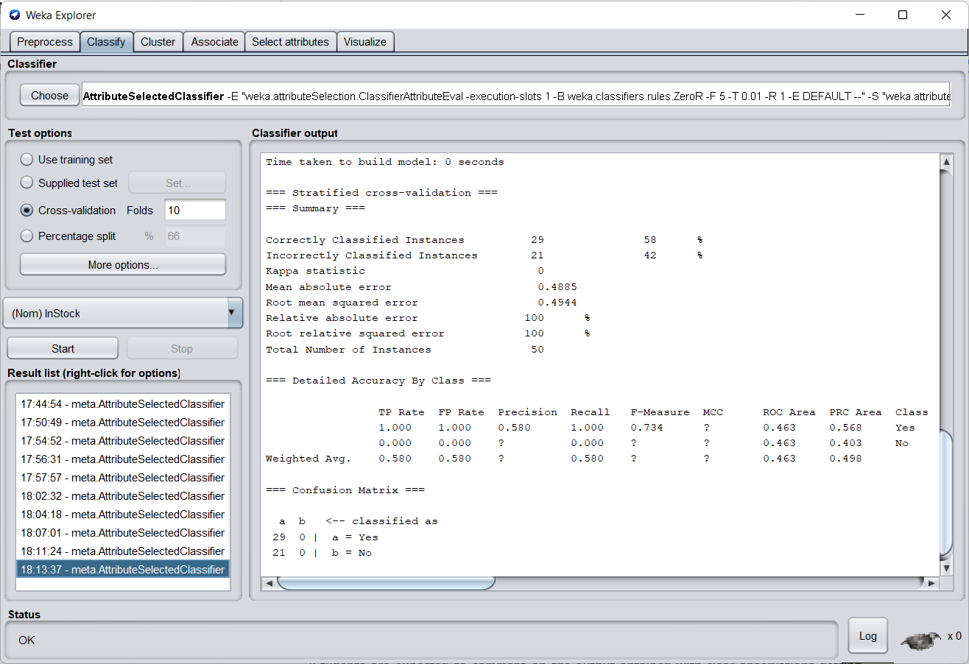
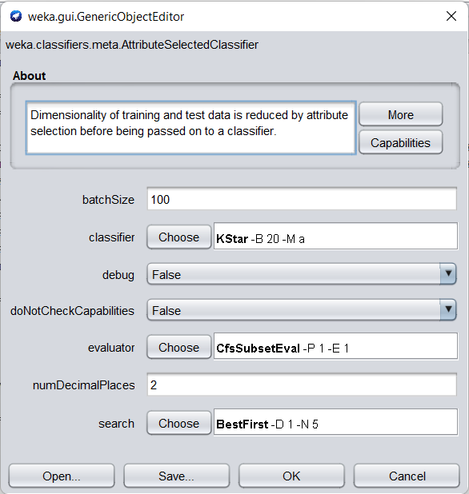
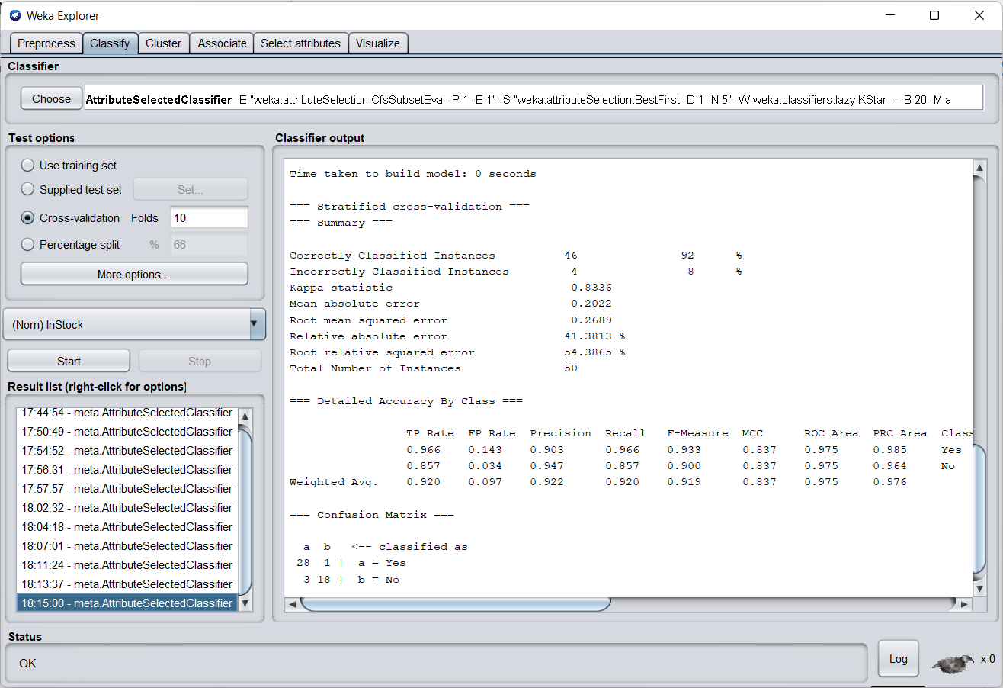
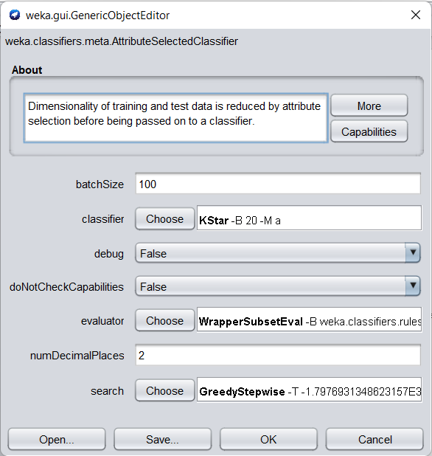
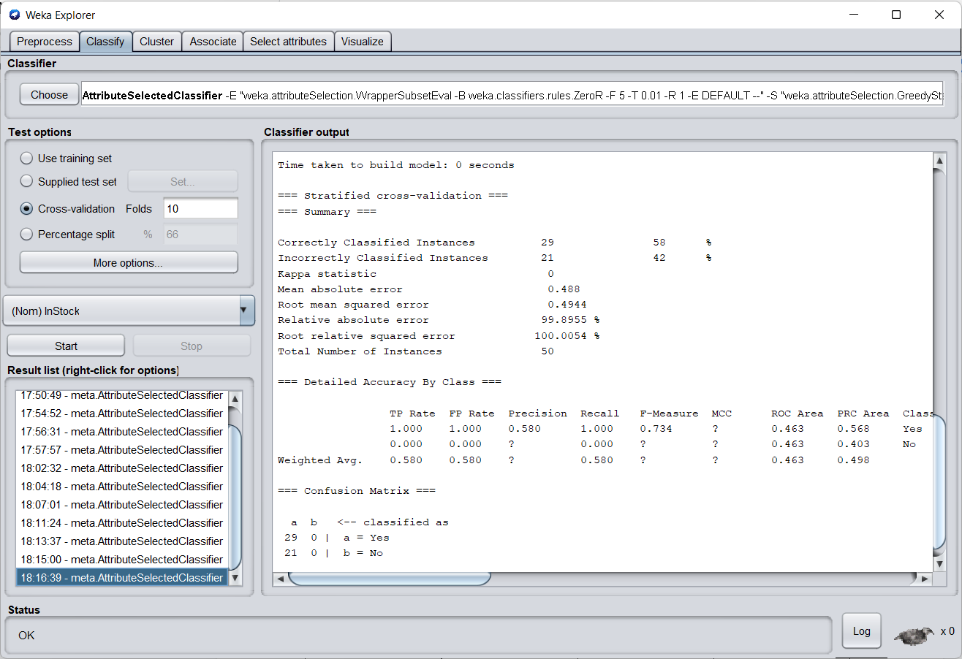
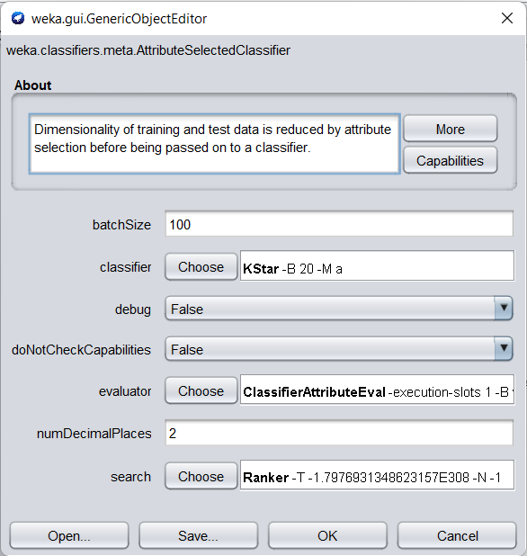
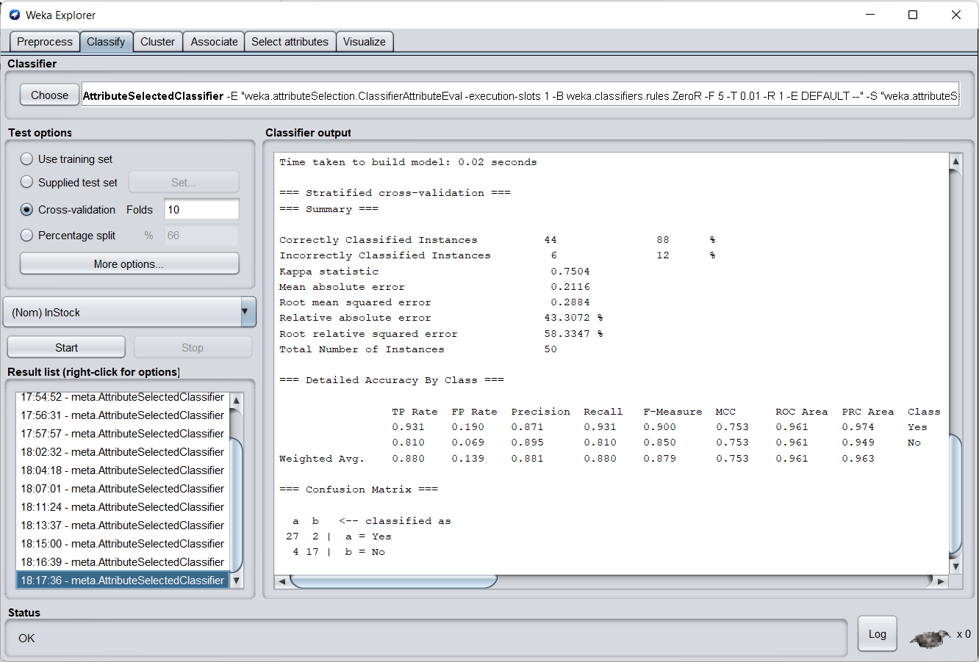
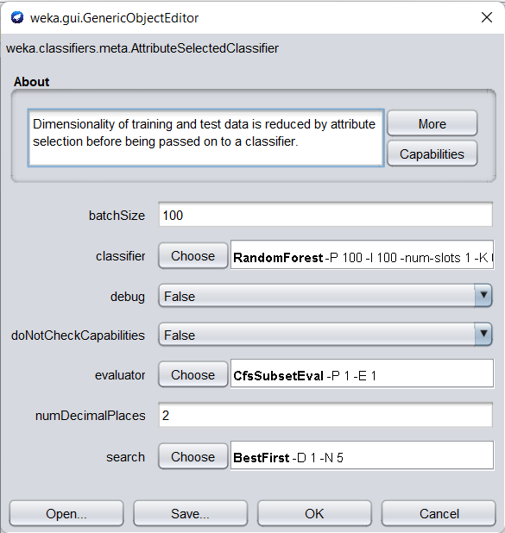
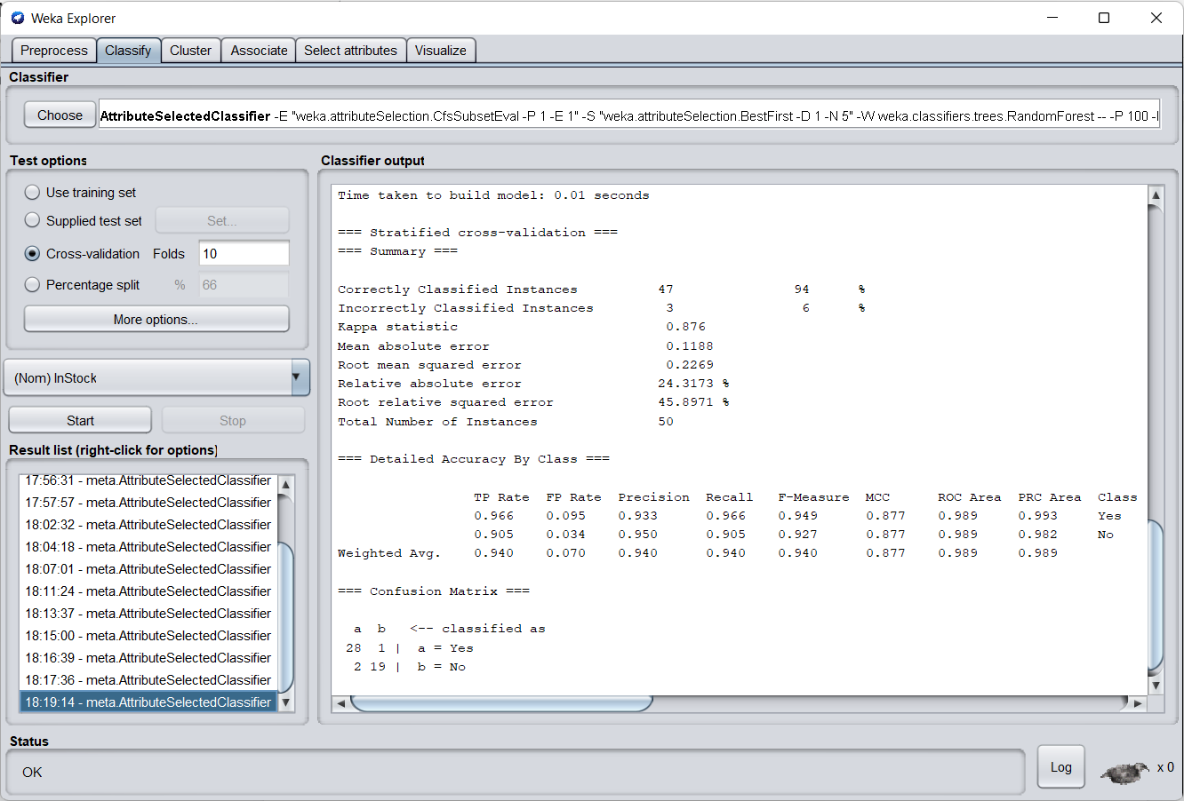
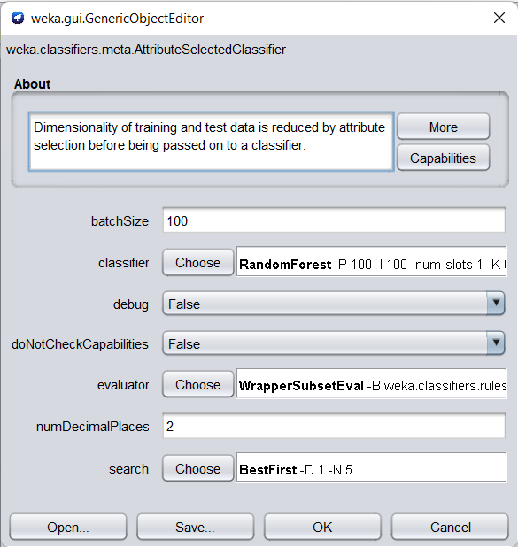
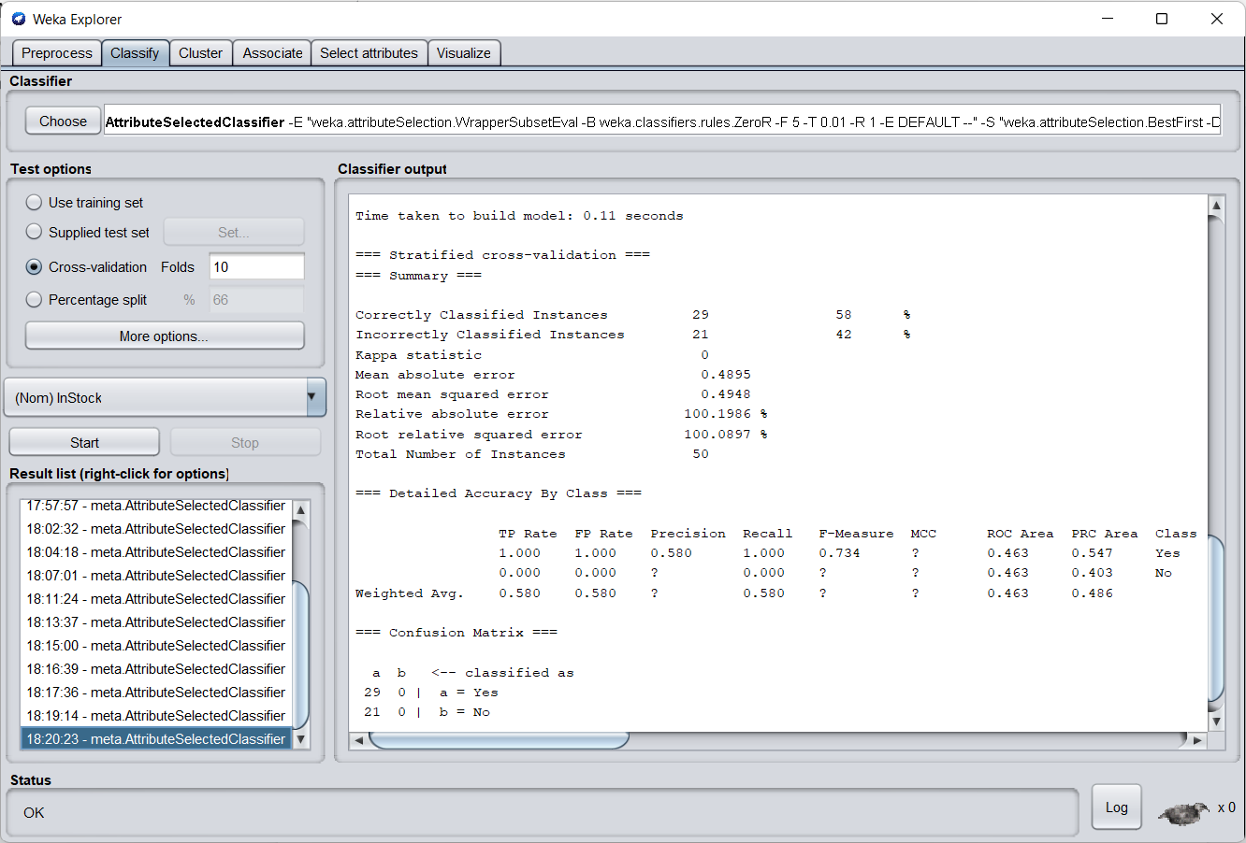
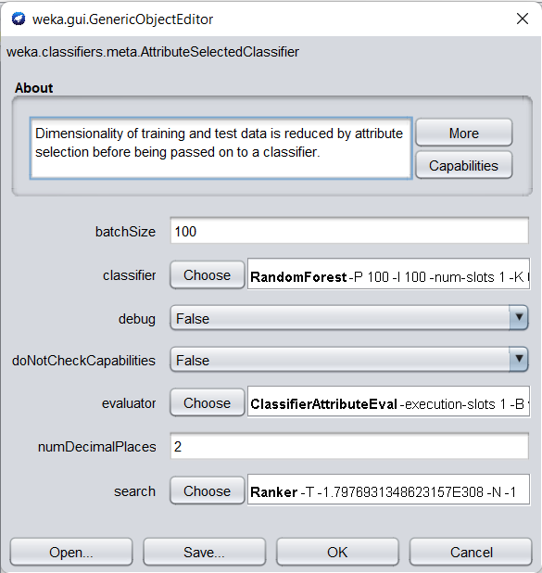
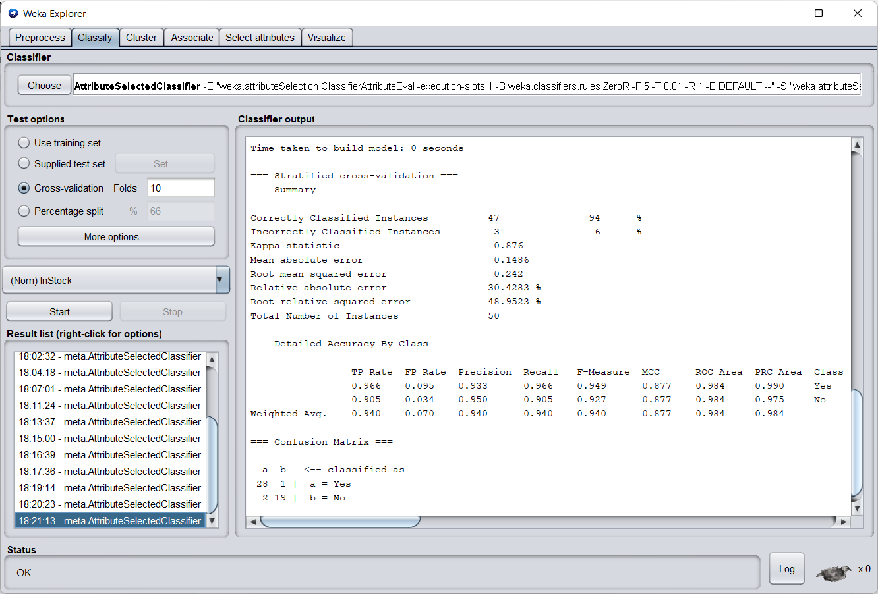
B.3 Observations and learning: (Performance Evaluation)
(Students are expected to comment on the output obtained with clear observations getting from Performance Evaluation after analyzing the data and learning for each task assigned)
CLASSIFIER | EVALUATOR | SEARCH METHOD | ACCURACY
J48 | CFS Subset | Best First | 88%
J48 | Wrapper Subset | Best First | 58%
J48 | Wrapper Subset | Greedy Stepwise | 58%
J48 | Classifier Attribute | Ranker | 88%
Naive Bayes | CFS Subset | Best First | 94%
Naive Bayes | Wrapper Subset | Greedy Stepwise | 58%
Naive Bayes | Classifier Attribute | Ranker | 94%
ZeroR | CFS Subset | Best First | 58%
ZeroR | Wrapper Subset | Best First | 58%
ZeroR | Classifier Attribute | Ranker | 58%
KStar | CFS Subset | Best First | 92%
KStar | Wrapper Subset | Greedy Stepwise | 58%
KStar | Classifier Attribute | Ranker | 88%
Random Forest | CFS Subset | Best First | 94%
Random Forest | Wrapper Subset | Best First | 58%
Random Forest | Classifier Attribute | Ranker | 94%

We can deduce the following from the given comparison:
- The least accurate classifier is the ZeroR, which is useful for defining a baseline performance as a standard for other classification algorithms.
- Greedy Stepwise Search has a lower accuracy than Best First and Ranker Search Algorithms.
- The Classifier Attribute and the CFS Subset Evaluator decide the most accuracy, while the Wrapper Subset Evaluator is accountable for the least accuracy.

B.4 Conclusion:
(Students must write the conclusion as per the attainment of individual outcome listed above and learning/observation noted in section B.3)
As a result, we were able to successfully incorporate a variety of problem-solving techniques while also optimising the accuracy for the provided dataset.
B.5 Question of Curiosity
(To be answered by student based on the practical performed and learning/observations)
Q1) What are the different methods for Relevant Attribute Selection?
Ans:
In the data mining process, Relevant Attribute Selection is a strategy for data minimization. Data reduction decreases the size of data so that it can be used more efficiently for analysis.
Attribute Subset Selection Methods
- Stepwise Forward Selection
- Stepwise Backward Elimination
- Combination of Forward Selection and Backward Elimination
- Decision Tree Induction
Q2) Explain Performance Evaluation Parameters for Classification Problem.
Ans:
- Confusion Matrix
The counts of test records successfully and erroneously predicted by the model are used to evaluate the performance of a classification model. The confusion matrix offers a more detailed view of not just a predictive model's performance, but also which classes are being forecasted correctly and erroneously, as well as the kind of errors that are being produced.
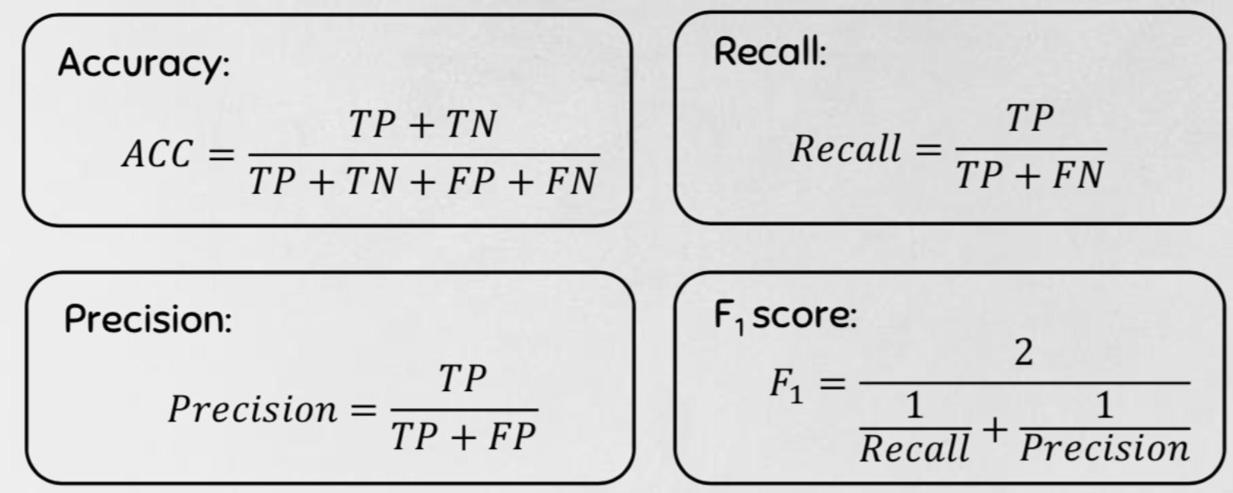
- Combining Precision and Recall — F1 Score
We aim to maximise either recall or accuracy at the expense of the other measure in the three examples above. For example, we would like to reduce FN to improve recall in the case of a good or bad loan categorization. However, in instances when we wish to discover the best balance of accuracy and recall, we may use the F1 score to combine the two measures.
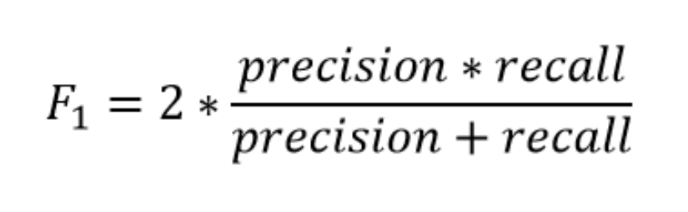
- Decision Threshold & Receiver Operating Characteristic (ROC) curve
The ROC plot is a popular method of displaying the performance of a classification model. It describes the trade-off between the true positive rate (tpr) and the false positive rate (fpr) for different probability thresholds in a prediction model.

